conical ball mill XMQ 240*90 laboratory small ball mill laboratory ore fine grinding

Small conical ball mill

single key calibration

automatic detection

light and versatile
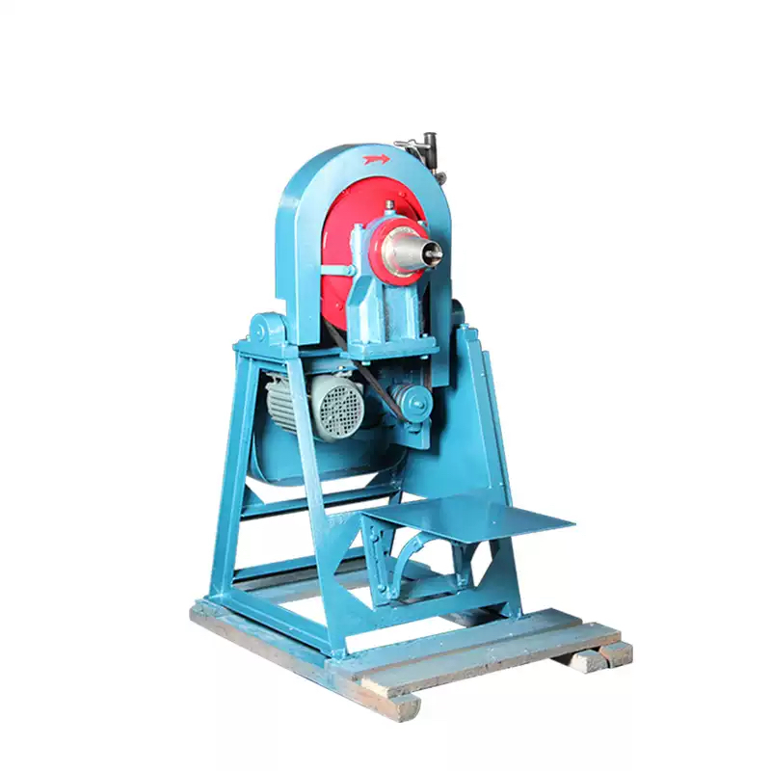

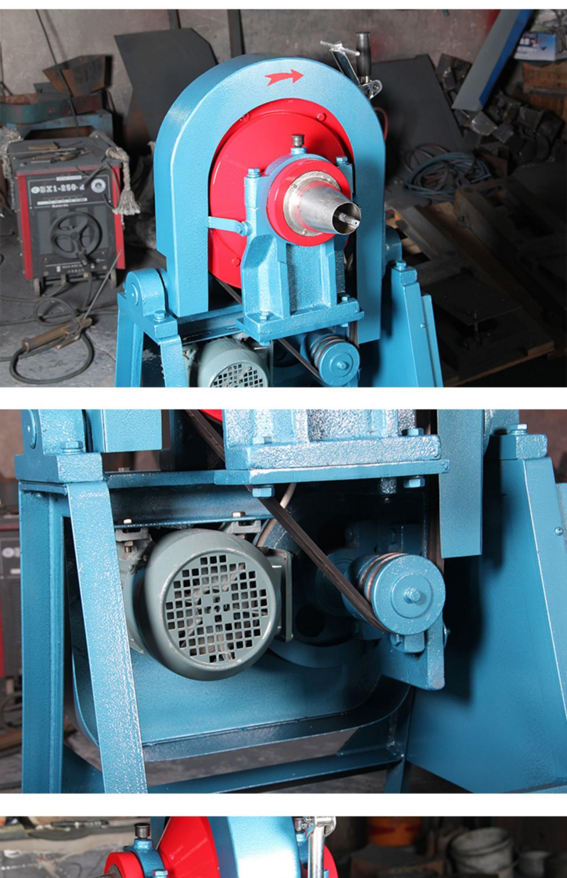
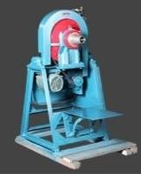
XMQ Series
This machine is anew type of smal,lightweight and multi-purpose grindingequipmentforlaboratory use
Formetallurgy,geology,chemical,buildingmaterials and coal mines and otherlaboratories,research units and
miningplantsforore beneficiability research work
grinding ore,but also formachinery,hydropower,light industry and agriculture and other aspects of the
experimental research work grindingasmallamount of materials.


Product
information

Model number | XMQ240×90
Ore supply | 500~1000克
Feed size | 3mm
Discharge size | -0.074mm
motor | 0.55kw
Overalldimension | 1052×640×1160mm
Machine weight | 170kg
Production equal to ore feed (instrument seal without loss)

Productsthooting

