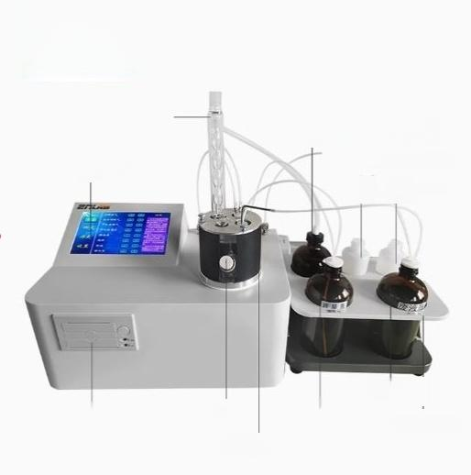
Product analysis
ELB-CS200 系 列 )

Return pipe
Recycle water bottle
Neutralizingliquid bottle Concentrated bye bottle
Touch screen

Waste liquid bottle
Reagent botle holder
Alcohol
bottle
Injection port
printer
Titration cell

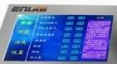

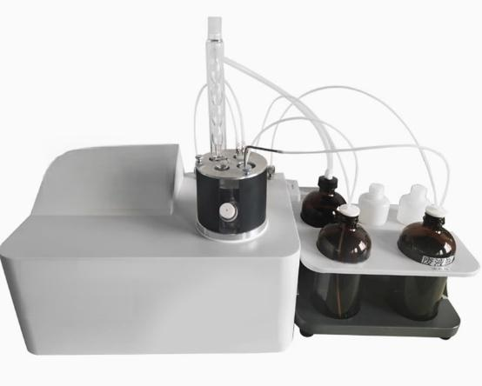

胸
、


Oil acid value tester

Reflux measurement -automatic storage of results

Query/print with heat-sensitive printer

Dark oleic acid value can be measured

Widely used

Widely used in power,petroleum,chemical,commodity inspection and scientific research and other fields,this product is suitable for detecting transformer oil,turbine oil,anti-fuel oil,diesel,gasoline and dark color of petroleum products acid value





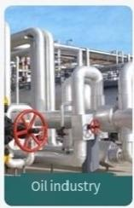




The process is fully automated without human intervention
The instrument adopts the principle of neutralization method, which is controlled by microcomputer at normal temperature to automatically complete liquid addition,titration,stirring, determination of titration end point,and automatic display of measurement results.The whole process is completed
5
automatically without manual intervention
Automatic storage of measurement results,can store at least 800 measurement results,can be queried,printed, equipped with a heat-sensitive printer
C

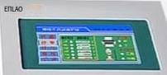
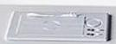


Programmed temperature heating bath automatically boiling reflux
The32-bit microprocessor is used as the main control core to automatically control the whole process of acid titration,automatically judge the color end point and automatically query the
data,which can easily find and print and store 100 groups of historical records

