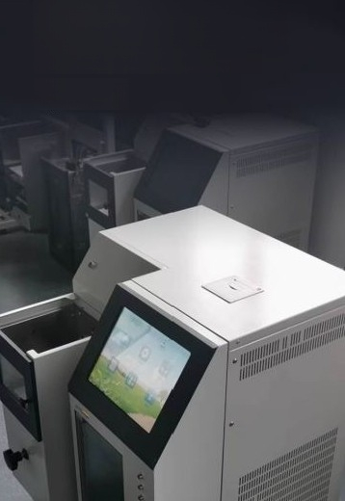
High precision liquid
level identification
system

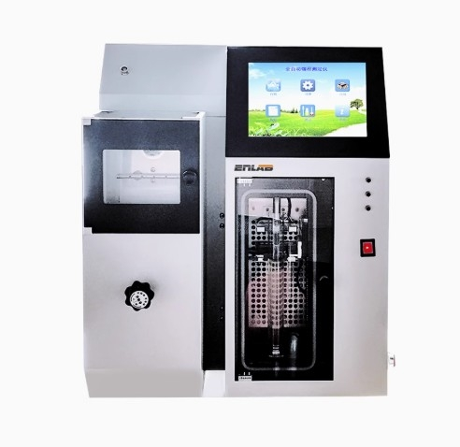


High temperature controlprecision 10.4 inch touch screen Fuzzy temperature control principle Large true color touch screen

Level tracking
Automatic detection
Automatic detection of localatmospheric pressure
High precision liquid levelidentfication system

阎

Fire extinguishing system can be
Cooling system
Compressorrefrigeration
manually nitrogen
fire

Scope of application


Suitablefor the determination of industrial volatile organic liquid,organic solvent used in raw materials,etc.Equipped with asuitable flask,it can also
be used for the distillation determination of gasoline,aviation gasoline
injection fuel,solvents with special boiling points,naphtha,diesel,distillate
fuel and similar petroleum products

Technical
parameters
product analysis

Heating chamber

Observation window

Lifting knob

The equipment is compact in structure,beautiful in shape and convenient in operation

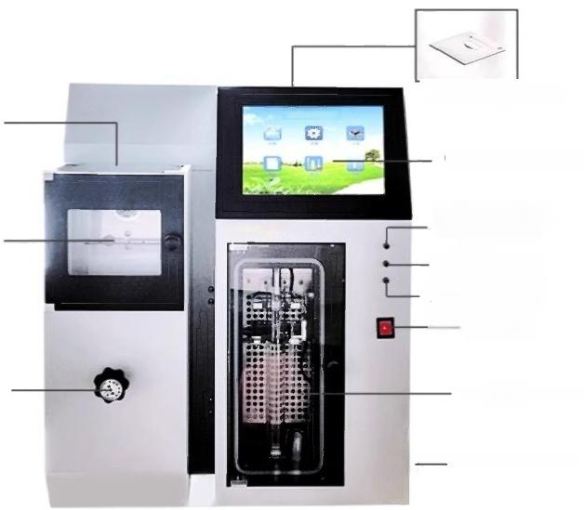
Printing device

Operation panel

Recovery chamber cooleroperatinglight
埃特拉德
Condensing tube indicator Heating furnace indicator Power switch

Collection chamber

Fire extinguishingswitch


High precision liquid
level identification
system

——
The instrument adopts imported high precision liquid level identification system,high precision liquid level tracking equipment compact structure, beautiful appearance,easy to operate

Instrument list

1.Complete sets of instruments

Serial  number | Te Weighing platform | unit | quantity
Two | "Distillation tester"main engine
one  Distilling Flask(125ml) |  |  | one
3 Thermometer (-2-400℃,division 1.0℃) |  |  | one
4 Glass cylinder(100ml,10ml) |  | only | Each 1
5 | Glass cylinder ④100×240 | only | one
6 weight |  | block | one
7 Rubber plug(4#) |  | only | 2
8 Thermometer Ring(1#) |  | only
9 Fuse 10A (φ5×20) |  | two | 2
10 Silicon carbide washer(④30,④50,notched) |  | block | Each 1
11 Power cord |  | The root
weve Window screen |  | Apiec | e  one

2.Technical documents
(1)Instruction manual part
(2)Product warranty part

