快压式密封环保制样粉碎机实验室密封式快速压紧物料粉碎机
LC-GJK fast pressure sealing sample preparation mill
Forced to use the wall
LC-GJKseries of fast pressure sealed sample mill is based on the original GJ series mill to add a fast pressure
pressing device and structural upgrade. It is suitable forcrushing coal,ore, rock or medium hardness non-metallic
substances and brittle metal substances in coal, electric power,scientific research and other industries and
departments. The sample size is uniform, the speed is fast, the work is reliable and the representative meets the
requirements. Sample preparation without screening can be used directly, fewer processes,high production
efficiency.Grinding chamberseal design, no dust pollution, in line with environmental requirements.Stable
operation, low noise, in line with safety production requirements.
LC-GJK100-3/LC-GJK100-3DLC-GJK100-4/LC-GJK100-4D/LC-GJK400-1D
New modifictions of the aibovemodels (as shown on the righo
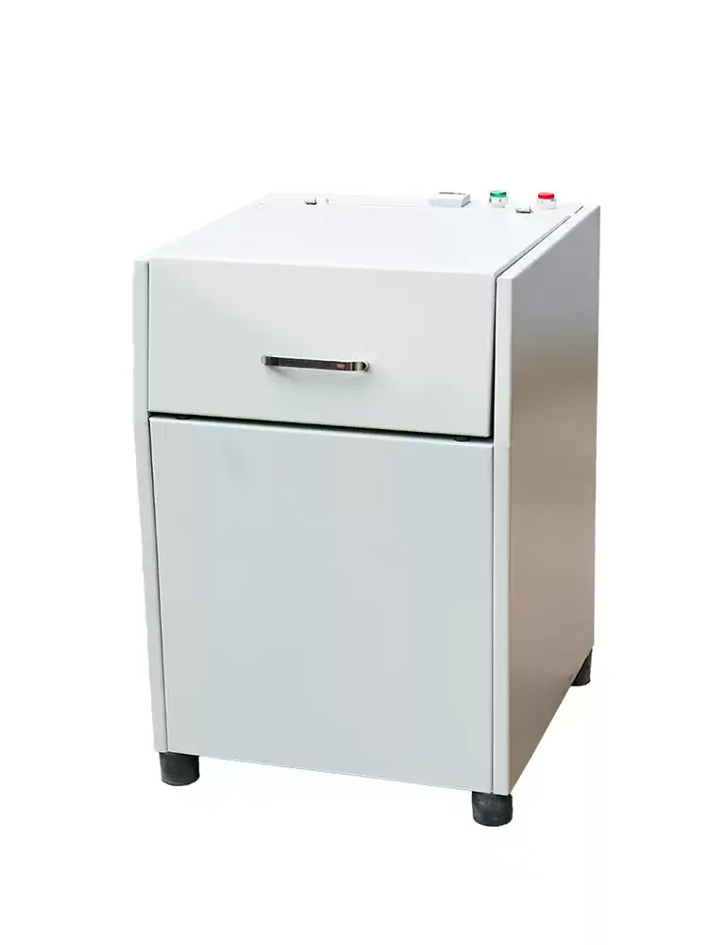
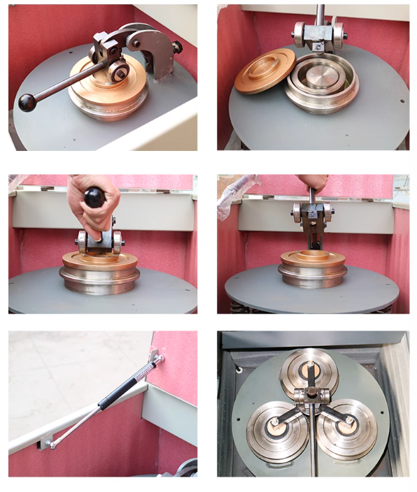
product details

