Instrument detail 01/02



The shell has a cold tie plate

Packingmachine with cold
bindingplate:sealed,safe and beautiful

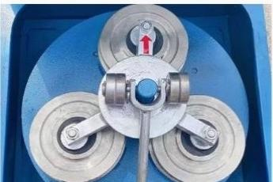

Multiple prototypes can be selected
Available on demand:
1 prototype
Two prototypes Three prototypes


Widely used
01/01
应用程序
It is widely used in construction industry,metallurgical industry,mining industry,coal, coking,chemical industry,non-ferrous metal smelting and other industries.
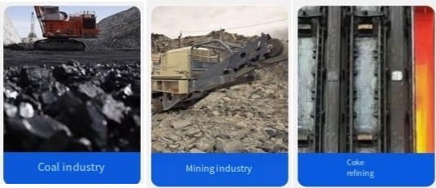




Functional characteristics 01/02
函 数
粉磨机
1,the shell with cold binding plate packaging machine:sealed,safe,beautiful;
2,the baseis cast with high-quality shockabsorbing materials:effectively curb the instability and vibration of the machine during work.
3,the shockabsorption part is composed of high-quality spring and rubber,the spring has high strength,high performance,high elasticity of the "three high" advantages,can effectively reduce the vibration to the lowest point,and then transmitted to the base.The bottom of the base is equipped with
shock-absorbingrubber pier to form adouble-acting shock-absorbing effect,
which can make the machine operate smoothly and reduce vibration and noise.
4,the power partis composed of motor,eccentric hammer,support cylinder,
etc.,when themotor starts,drive the eccentric hammer to rotate.Due to the
action of different centers and eccentric hammers,a high-speed circumferential movement isformed,and this movement is transmitted to the grinding part.The support cylinder plays the role of connecting up and down,because the support cylinder isaclosed device,and plays thecontrol of the unsafe accident caused by the severe vibration of the eccentric
5,the pressing device is composed of pressing lever,pressing bending wheel and speed pressing,its role is to fixthe grinding parts tightly on the vibration plate,so that the power is effectively transmitted,and can play a safety role.The pressing part of the machine is advanced,different from other machines,advantages:fast and safe,simple operation,adjustableup and down,to solve the phenomenon of unsafe and slow pressing

Packing list 01/06

Serial number | name | quantity
one | Host machine | A set
2 | Correspondngaccessories | A set
4 | nstruction manual | part
5 | Certificate/Wamanty card | part

