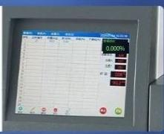

Detail
presentation

01.
Touch LCD /
10.4 inch working colortouchscreen, intuitive display,intuitive control

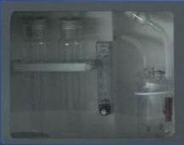
03.
Searchable print

Support recent experimental data storage,and print data

02.
Viewable large window

View processes at any time

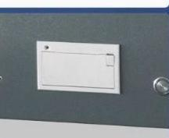

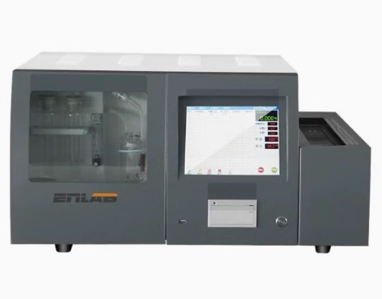


Field of use-Product use

It is mainly used forthe determination of total sulfurcontent of coal,heavy oiland othersubstances



Scientific
electricity
research

Stone heating
Various minerals
Coal detection

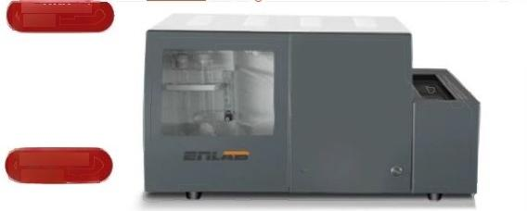
MICrOcomputer model

Touchscreen version

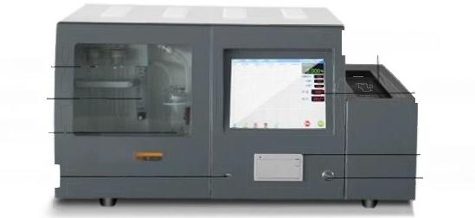
Sample chain

Digital touchscreen
Dryingpipe flowmeter Electrobytic

cell
printer
1
TE
Power switch
USB interface

Model number | 24 kinds of microcomputer automatic sulfur meter | 24 kinds of touch screen automatic sulfur meter
Neruingrange | 0.01%-60%,resolution 0.01 0.01%-60%,resolution 0.01(optional0.001grade)
Single maximum lofting twenty-four |  | 24 PCS(optional20-30 PCS)
Analysis time Hutomaticaly determine the end point of the experiment habout hutomaticaly determine the end point ofthe experiment tgeneray³-45
5minutes/time) m nutes/sample
Warming time | Ambient temperature start 15-25minutes | Ambient temperature Start15-25 minutes  700C-1190℃,the target temperature can be set freely(ultra-low temperature is optional
Temperature 700℃-1190℃,the target temperature can be set freely contro
Precision Temperature | ±2.5℃
controiPoweF supply | 220V±20V,50Hz cracking furnace instantaneous maximum power s2.5Kw
Sample quaity | Support quality input range from 10mg to 999.9mg
accuracy | In line with the national standard GBT214-2007 standard sample allowable error range

  High degree of automation |   明
Microcomputer model&Touch screen model

自动化程度高
Automatic control of stirring start and stop and speed;Automatic control of the gas circuit to automatically determine the end of the experiment
● Adopt high-precision power transmission principle,precise control,eliminate the card sample using long-life air
pump,stable working performance,adaptive resistance value of silicon carbide tube,longer life

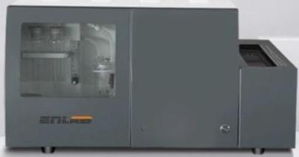

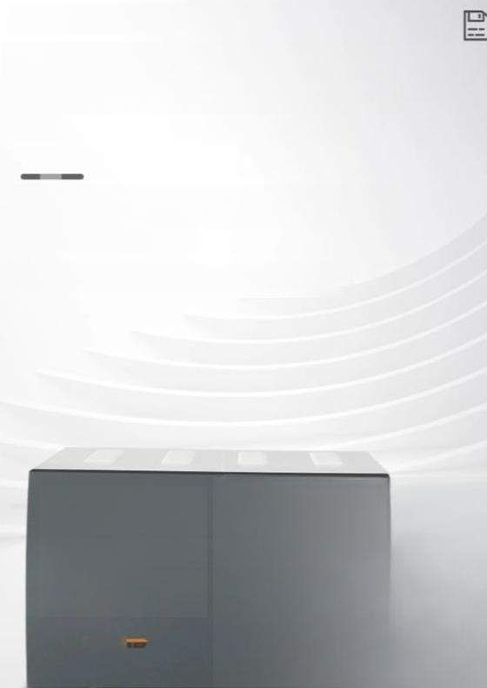
24 touch screen models
Supports the "continuous rolling" storage of 2000 recent experimental data

With experimental data export function,to realize the custom printing of reports(microcomputer upgrade version is optional)
Safe and reliable|durable|precise control

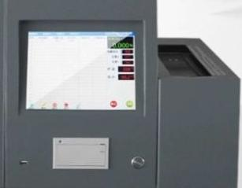
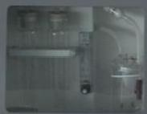
I

Packing list
24 microcomputer models

Serial number | name
cne | Sulfur meter main engine
2 | computer
3 | printer
4  5 | Silicon  carbon tube  Reducing combustion chamber
6 | Special Svalue indexing thermocouple
7 | ntegrating cell
8 | High temperature feed rod
9 | High temperature quart plate boat
10 | High temperature sampleboat
11 | magnet agitator
twelve | silicagel small rubber plug
13 | The serial portconnects to the data cable
fourteen | Seal camp
15 | tweezers
16 | Medicina ladle
17  18 | Color-changing  silicagel  Special electiolyte forcoulomb flow measurement
19 | Sample box
20 | Debug thestandard coal instrument
21 | software
22 | Air filter
23 | Fluorine hose(6*10)
24 | right Angle bracket
25 | specification
26 | Certificate of confomity

24 touchscreen models
)

Automatic diversification of rapid sulfur measuring equipmenthost |  | A set
Special superalloy sample delivery rod |  | A root
Sulfur type Sthermocouple |  | A set
Sicon carbon tube laithshconcarbon titecpandhigh temperature lead |  | Aset
Reducing pipe |  | two
Coulomb integral cell/cracking cell |  | A set
Three sets of electrolytic cell | (Stirrer+clamp+electrolysis  Pool inlet filter) | A set
High quality siliconetube |  | 0.5meters
Special discard sample storage box |  | A set
Dedicated quartz boat | Dedicated 2
Special porcelain boat |  | twenty
electrolyte | 1 for debugging | part
Standard coal sample
Color-changing silica gel | Hbottlefor debuggi | ng
2-piece experiment kit (spoon+tweezers) |  | part
Supporting instructions+packing list+Certificate |  | A set

