
Electromagnetic balance sensor intelligent "core" experience
The use of electronic control technology,the use of electronic devices to complete the electromagnetic force compensation to achieve
torque balance,to complete accurate weighing


Up to 500g bearing capacity gives sufficient stability and a sense of security

A variety of range options to meet a variety of weighing range needs

10,000-position
balance 100-320g
5ranges available

Micrometer
balance 100-500g4 ranges available

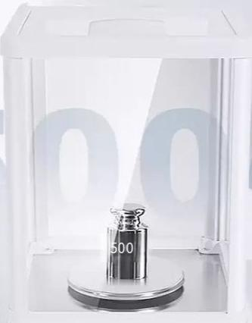
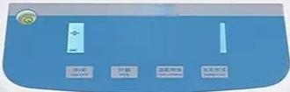
SUnnE
S00000。

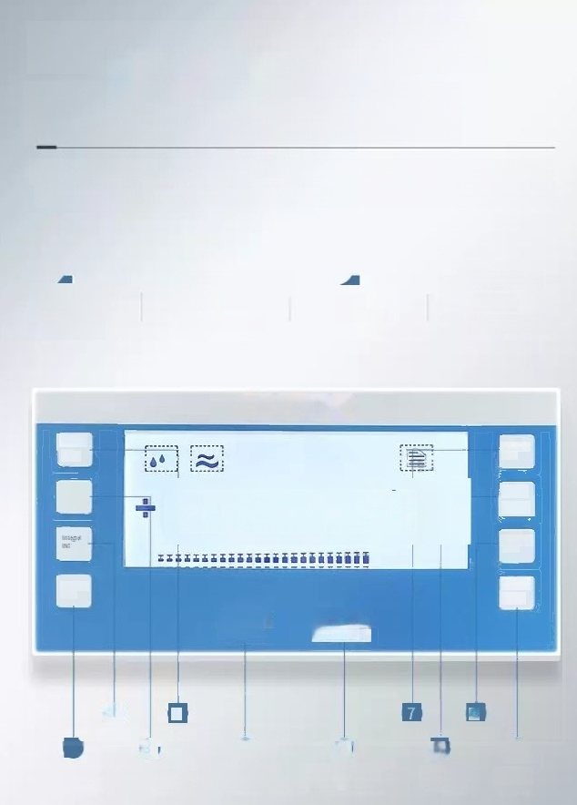
Hd LCD screen interface
simple 10 keys to tune
LCD HD night vision large screen,reading at aglance counting,peeling, calibration,units,printing,sensitivity,integral time,all one key control

4
sensitivities

4 levels
Credit duration

1-key
calibration

Multi-unit Smart
conversion

Tum
cibae
CAL
ON

100.0000克
Unit
UNT
Countng cou

Serstike SD
Print
PRT
SHZERO/pee ZERO/TAR
2ERO/peel ZERO/TAR

2
9
Counting
4
Boot
Points
Calibrate
8
6
Zero/peel
10
Print
51
Zero/peel
Sensitive
unit
Power Off



Stable,accurate and fast balance must be stable, accurate and fast




High precision sensor Hd LCD screen
One-click calibration




Connectyour computer/printer Touch feedback key
Four-level shock protection




Multiunit conversion Zero and peel
个人电 脑

Countingfunction

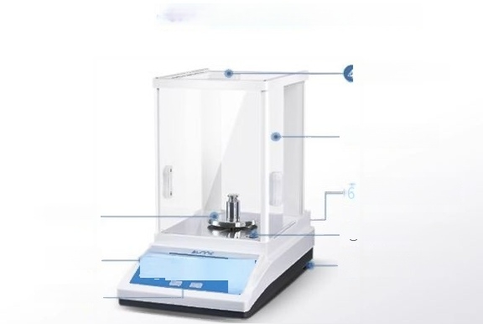
SN-FA series ten-thousand-digit balance

Pull the handle

⑤ Door glass

RS232 interface(back) Power interface(back
Weighing plate①
⑦Horizontal bubble
机0000
Key ② Monitor③
目
⑧Horizontaladjustment nut

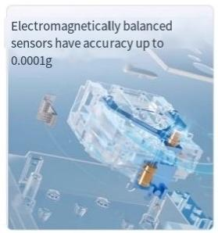
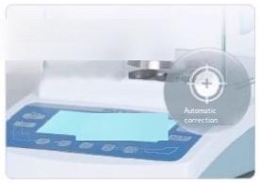
Automatic internal calibration
Improved calibration efficiency

ao00
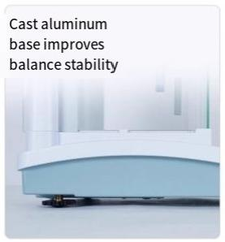


Parameter function
adjustment sensitivity,
integration time adjustable

Sensitivity ASD
Integral INT

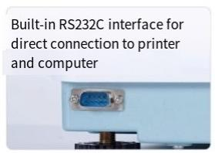
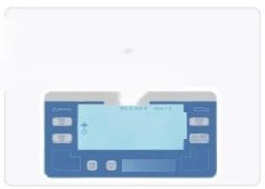
LCD Liquid crystal High contrast for clear display
SUmE
588890
0 日


304 stainless steel pan easy to clean without dust
Through the 080-90mm size round pan,to achieve balance on the scale is not easy to deform thickened stainless steel
material,soft cloth can be cleaned

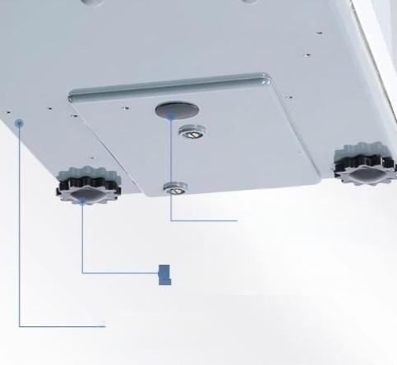
Underweight function
one
Weigh samplesofiregularshape
ABS Adjusting feet
Easily level to reduce interference
Aluminumalloy base texture more stable
3


Packing list
List of standard fittings on display

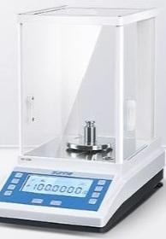
SN-FA Series(Product model)
aaoo004
SN-FA1004 SN-FA1204 SN-FA2004 SN-FA2204 SN-FA3204

Master supply list
①One main machine ② Weight 1
41power cord ⑤1 copy of product manual

③ Stainless steel pan 1
⑥Certificate/waranty card 1 copy

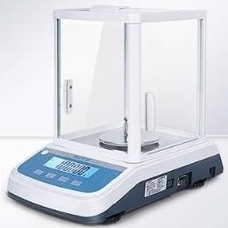

SN-TF Series(Product model)
SN-TF1003 SN-TF2003 SN-TF3003 SN-TF5003

Master supply list
① One main machine ②Weight1
4 One power cable ⑤1 copy of product manual

③ Stainless steel pan1
⑥Certificate/waranty card 1 copy

