Three pallet clamps to suit different container and sample needs

Single-layer flat tray:suitable for petri dishes,culture bottles,centrifugal tubes and other containers;Spring jig,adjustable clamp rod:suitable for conical bottles,beakers and other containers(note:When using these two jigs with large capacity,please set the speed below 240rpm).

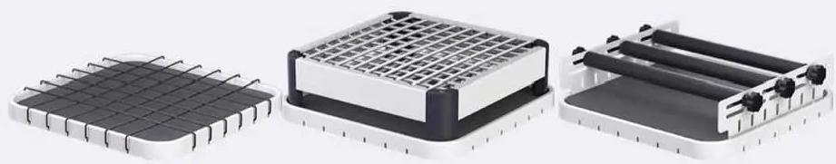
Single-layer flat tray Spring multipurpose jig
Adjustable clamp rod suitable for running track:
circular,linear

Applicable running track: circular,linear,warped plate,three-dimensional

Applicable running track:circular,
linear

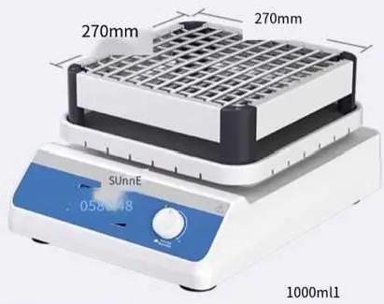
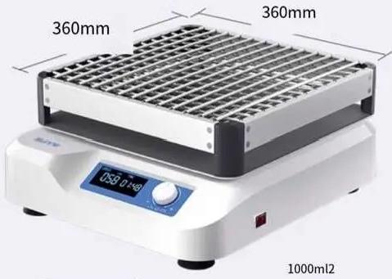

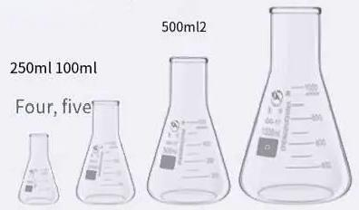
Tray capacity: Tray capacity:
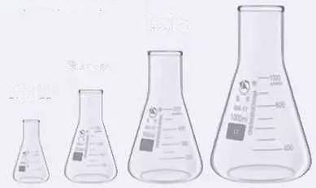
500ml5

250ml9
100ml12

一

Functional analysis to master the advantages

PRODUCT FEATURES

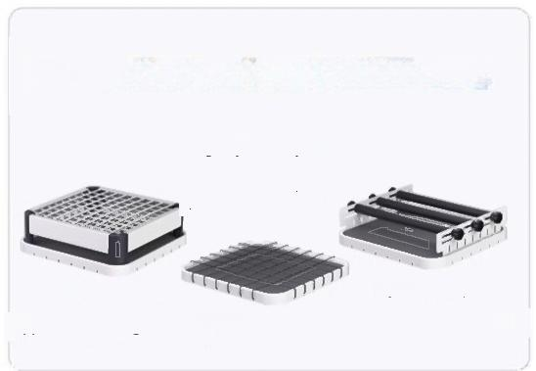
Three kinds of pallet fixtures

Single-layer flat tray is
suitable for running track:
circular,linear,warped
plate,three-dimensional

Spring multipurposejig
Applicablerunningtrack:circular,linear
Adjustable clamp bar
Applicable runningtrack:circular,linear



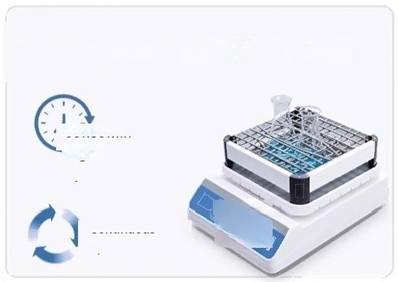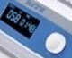
Dual mode optional(T-limited)

99h59min regular
operation

Continuous operation

Small body with large load bearing
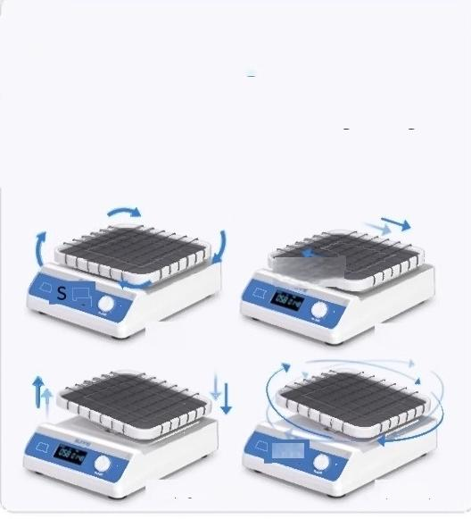
Four running tracks
Circular,linear suitable for oscillating mixing Warped plate,3D suitable for flexible mixing

T

(Circular operation) (Linear run)

BSB
Warping board run) (3D run)

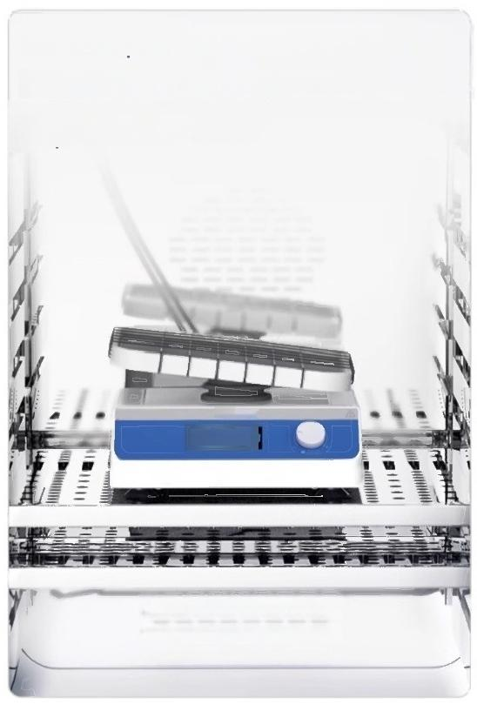
Can be put into an incubator
for use in decolorization
experiments

sumE
OSB D:4

Wide voltage design

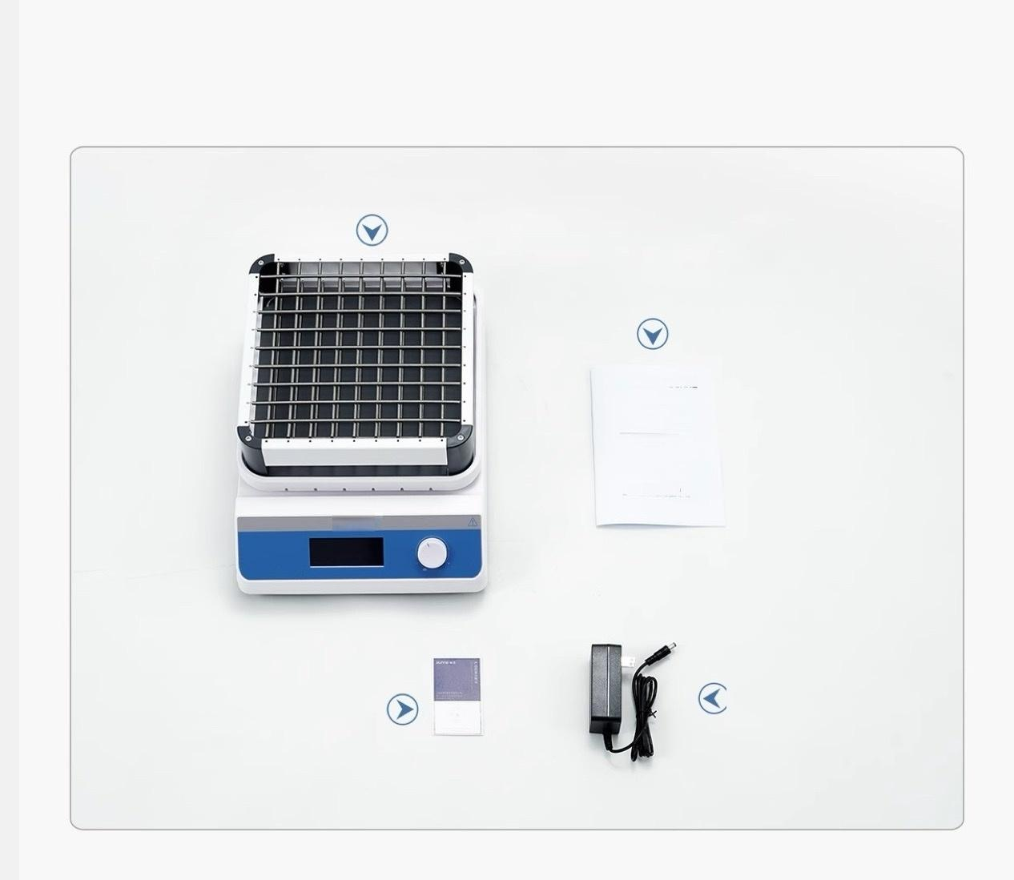  Instrument list display | DETAIL  DISPLAY
Host machine

Instruction Manual

SunOG

Table bed
Instruction manual

SUnNE

Power adapter
Certificate/Warranty card

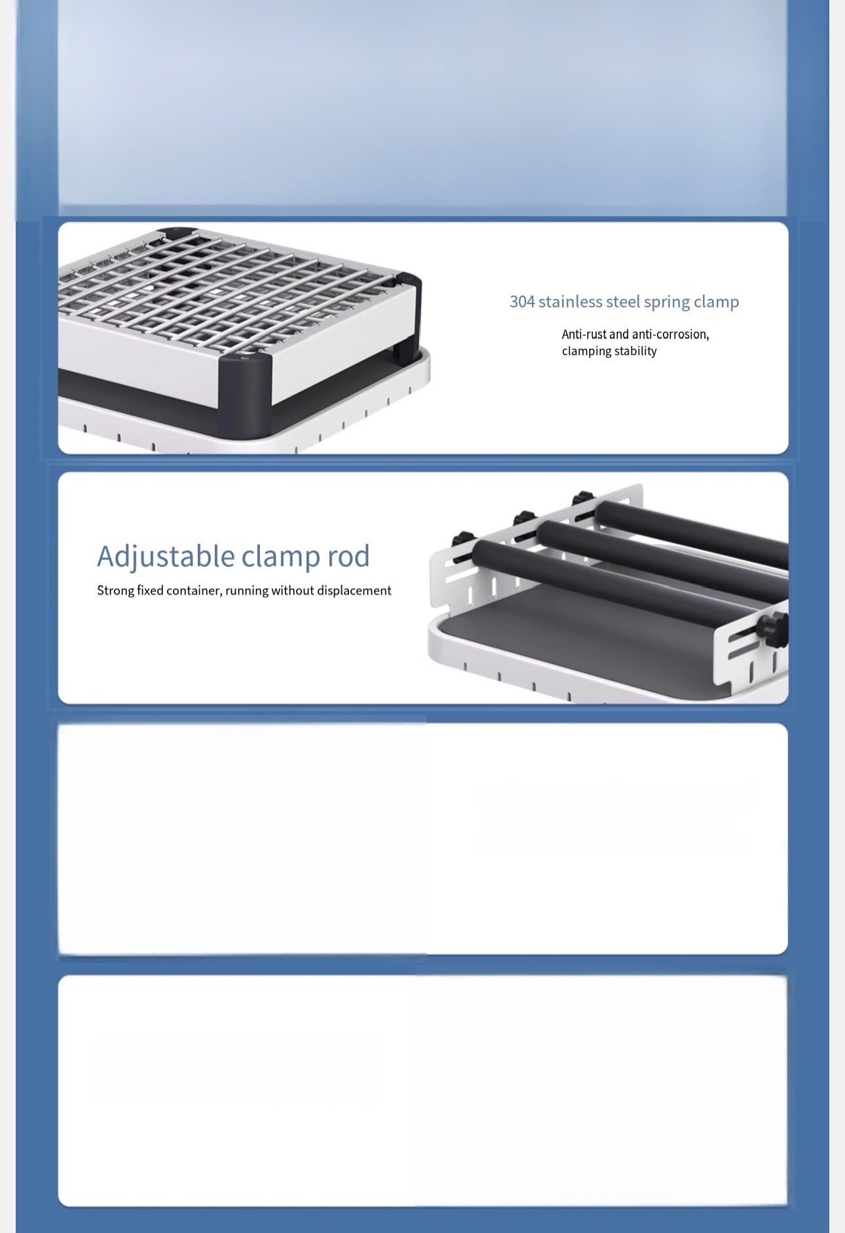
Instrument detail display
DETAIL DISPLAY

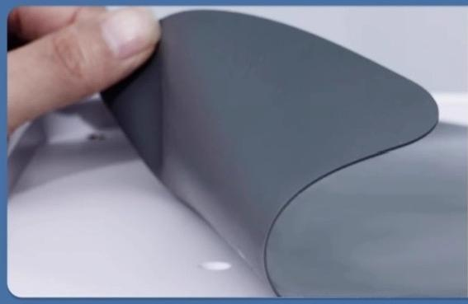

Rubber shock-proof suction cup foot makes the instrument suitable for
high and low speed stable operation

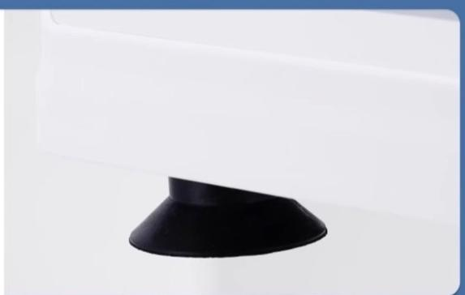

Non-slip silicone pad
Make the container non-slip and run stable

