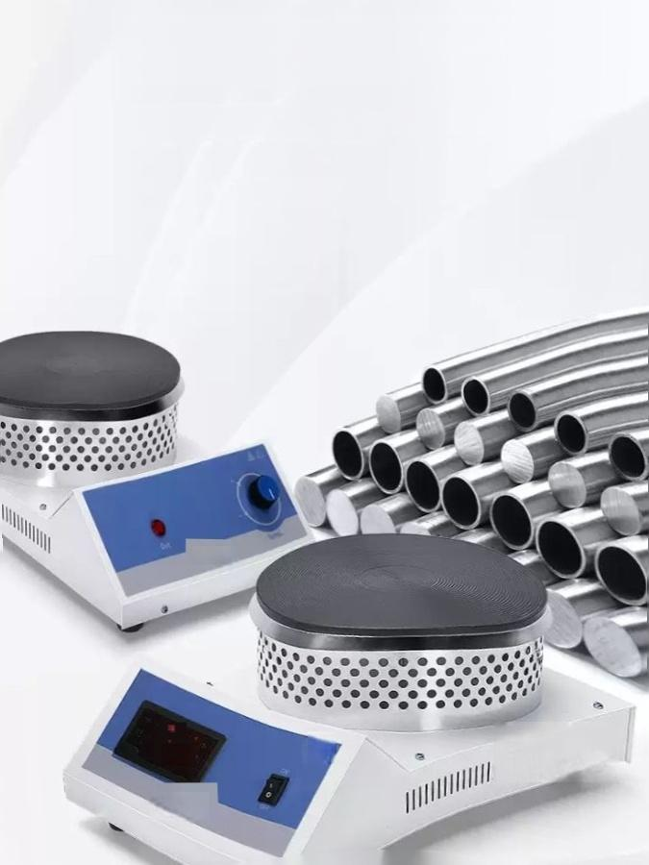
High quality steel casing

Electrostatic spray processingtechnology,anti-corrosion,anti-aging
0●0

SUNNE
6

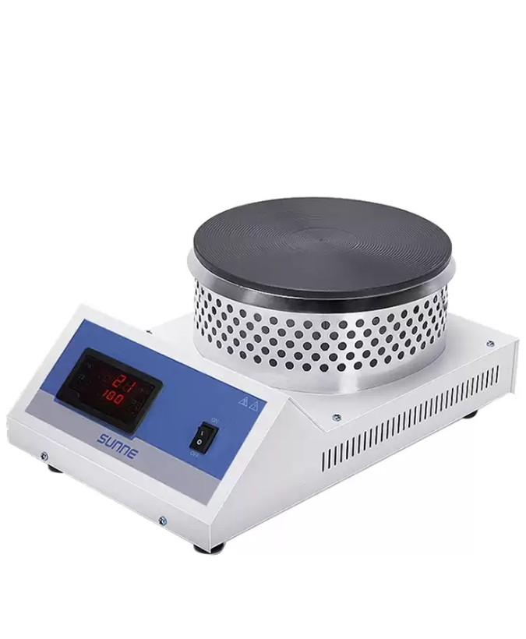

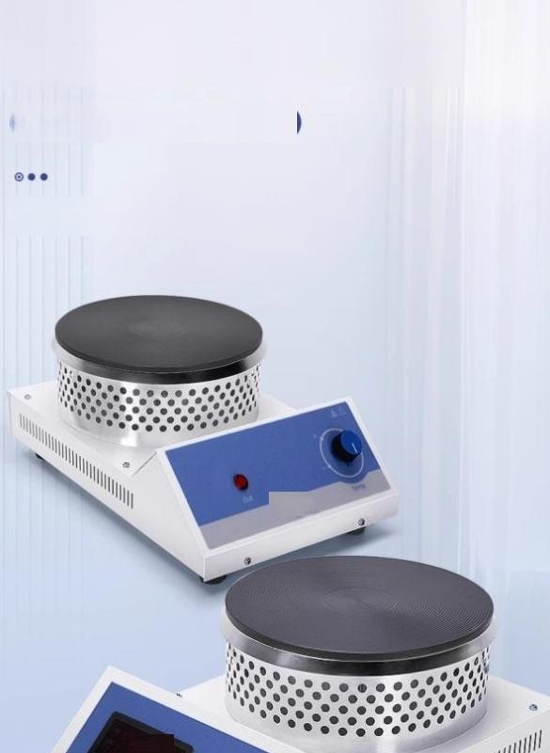
Far infrared closed electric
furnace
Heating fast flame for a wide range of
applications

远红外封闭式电炉

SUnnE

e10

Multifunctional experience


sensor
Blind fire
Instrument self-tuning function
Error correction



。
Rapid warming Uniform temperature Safe and reliable

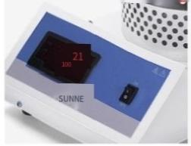
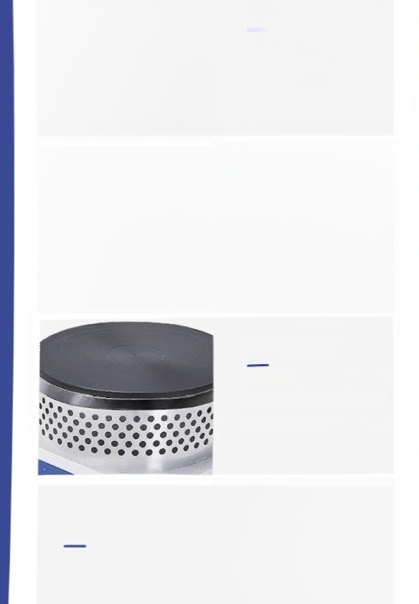
Panel display(digital display)
LED digital tube display set temperature and
current temperature, clear and intuitive

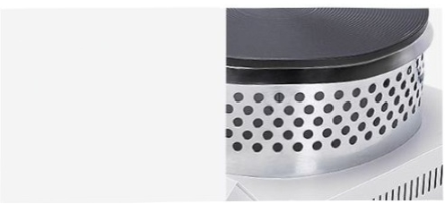
Heat insulation ring
Prevent miscontact

Heating plate

High temperature resistant coatingcast iron Heatngplate,high hardnes,hightempeature
No warping deformation,service life 长
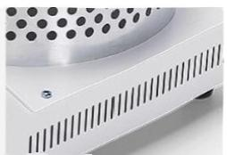

Heat sink
Multiple heat dssipation ports,wntilation and heat dssipation

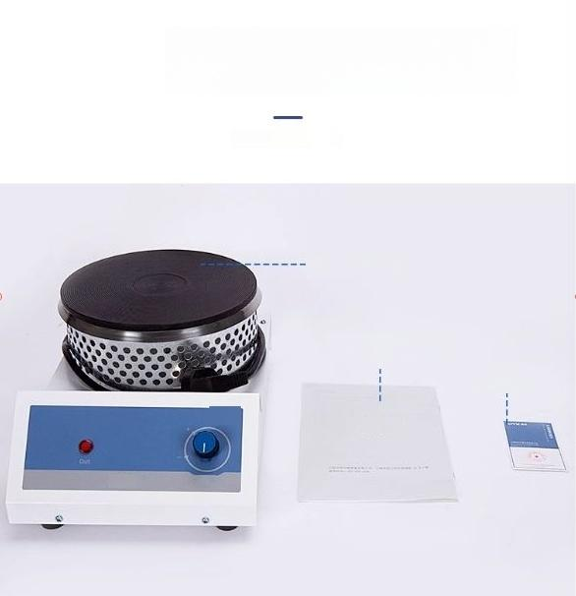
Product packing

Host machine

specification
Certifcate of conformty

sunN区c

SUNNE

